
SOCIAL MEDIA TOURISM
Capstone Project - Business Report

January 30, 2022
pgp-dsba 2021-2022

Table of Contents
1. Problem Understanding 2
a) Defining Problem Statement 2
b) Need of the study/project 3
c) Understanding Business/Social opportunity 3
2. Data Report 4
a) Understanding how data was collected in terms of time, frequency and methodology 4
b) Visual inspection of data (rows, columns, descriptive details) 4
c) Understanding of attributes (variables info, renaming if required) 6
3. Exploratory Data Analysis 8
a) Dropping Unwanted columns 8
b) Null/Missing value check in each columns 9
c) Univariate Analysis of Categorical variables: 11
d) Outliers using box plot 25
e) Correlation between variables using Heatmap 29
4) Business Insights from EDA 30
a) Is the data unbalanced? If so, what can be done? Please explain in the context of the business. 30
b) Business Insights: 31

Capstone Project – Social Media Tourism

  - Problem Statement
An aviation company that provides domestic as well as international trips to the customers now wants to apply a targeted approach instead of reaching out to each of the customers. This time they want to do it digitally instead of tele calling. Hence they have collaborated with a social networking platform, so they can learn the digital and social behavior of the customers and provide the digital advertisement on the user page of the targeted customers who have a high propensity to take up the product.
Propensity of buying tickets is different for different login devices. Hence, you have to create 2 models separately for Laptop and Mobile. [Anything which is not a laptop can be considered as mobile phone usage.]
Note: The advertisements on the digital platform are bit expensive, hence you need to be very accurate while creating the models.

1. Problem Understanding

a) Defining Problem Statement
The given problem statement is regarding an aviation company that provides all kind of air services to their passengers. The company provides domestic as well as international trips to the customers from one place to another. Company wants to attract more customers to use their business services and for this, it reach out to the audience by the process called tele-calling. Now the company wants to grow their business and for doing so, they need to reach as many customers as they can. So this time, instead of using the old and same traditional way of attracting customers, they want to apply a targeted approach to reach out to the large audiences. So the company has decided to collaborate with social media platforms so that they can utilize the socially available data or information about the travelers and can learn how the customers behaves socially regarding the travel and tourism services and what kind of places they usually visit on yearly or monthly basis. Company want to do some kind of data analysis to understand the attitude of the customers towards their company’s business and also want to analyze the travelling patterns that customers follow. It also want to know more about the nature of using the social media by getting the information like, which device the customer use to book the tickets, how long the user is spending their time on the company’s page, and so on. Now the business management team planning to utilize this data and want to provide the digital advertisement on the user’s page of the selected and targeted customers who have the high propensity to take up the product. By doing so, the company can grow its overall sales and improve its revenue.

b) Need of the study/project
Every company wish to expand their business locally and globally in their working sector and also want to improve their services for their customers so that more and more number of people take their product.
Here the need of this particular project is also the same. Business team has found out that they need to change the way the company deals with the process of reaching out to the audience. Collaboration with the social media platforms is an effective way to gather the information and utilize it systematically and properly can get their business the new heights. By understanding the customers travelling pattern socially, they can be more accurate about targeting the users who has the high chance of taking up the product instead of doing the same way of random tele-calling kind of process.
Company uses the gathered data to gain some useful insights from it and then make changes accordingly in their process of doing business.

c) Understanding Business/Social opportunity

Now-a-days social media is not just there for entertainment purpose. It has various prospects and by utilizing the power of it, every individual or organization can get the opportunity to transform as they want. Companies can reach out to large audiences with the help of it and can increase its visibility by being active on various social media platforms for the improvement of the business. At the same time customers can reach out to the company’s page and get their updates and important information about it and get benefits of their products and services.
This will help not only the company to understand the need of the customer but also the customers understand the company’s work ethics and its value in the market.
Similarly, here in our case, the aviation company want to take the benefits/advantages of the power of social media and utilizing their data that has been collected over the period of time to get some insights and make favorable changes in the execution of their business.

2. Data Report
a) Understanding how data was collected in terms of time, frequency and methodology:
At first glance, by looking at the columns in the dataset we can say that the data has been collected based on users’ profiles that mentions whether the user is adult or not, user is working or not, number of members in their family, user’s close friends who also like travelling and in terms of time and frequency there are columns which has yearly and monthly average records also and it has also captured the data which mentions average time spend on the company page by user on daily basis.

b) Visual inspection of data (rows, columns, descriptive details)
- Variable names and their description:
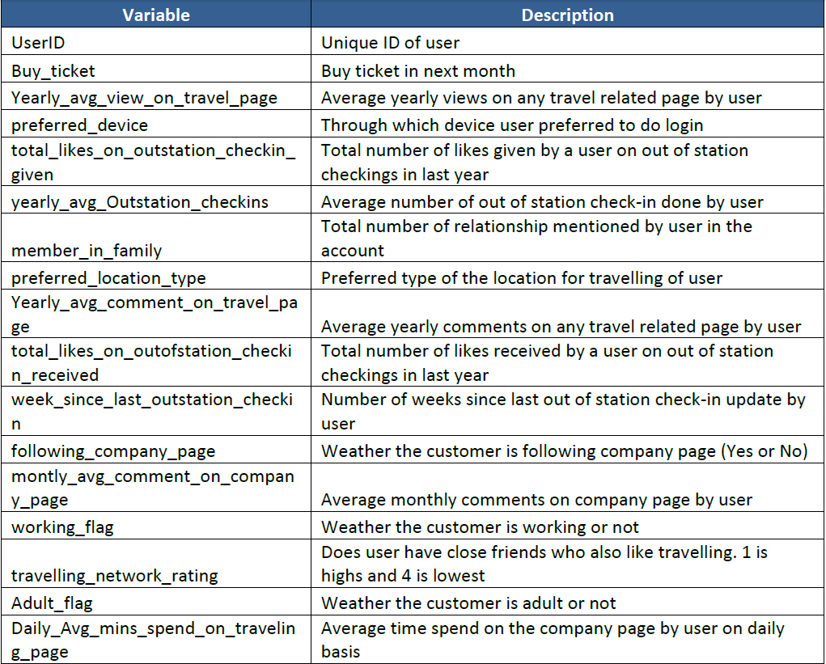
- Shape and Size of dataset:
Total number of rows in the dataset: 11760
Total number of columns in the dataset: 17
Size of the dataset: 199920

- Data Types of each variable:
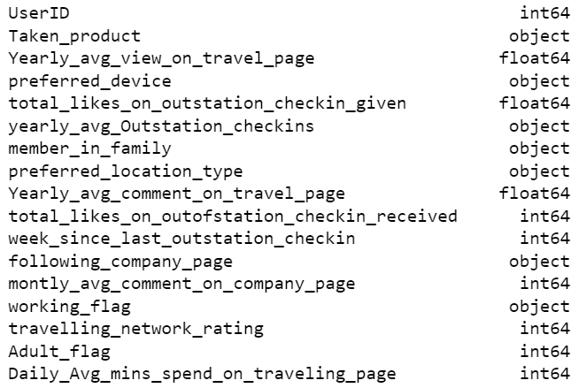

- Descriptive details and five number summary
Let’s look at the descriptive statistics details of the data and understand how the data actually is in terms of five number summary.
The describe function is used to generate descriptive statistics that summarize the central tendency, dispersion and shape of a dataset's distribution, excluding Nan values.
We can get the count, mean, standard deviation, minimum, maximum, 25%, 50%, 75% of each of the numeric variables in the dataset using describe function.
Let’s look at the below figure to understand it in better way.
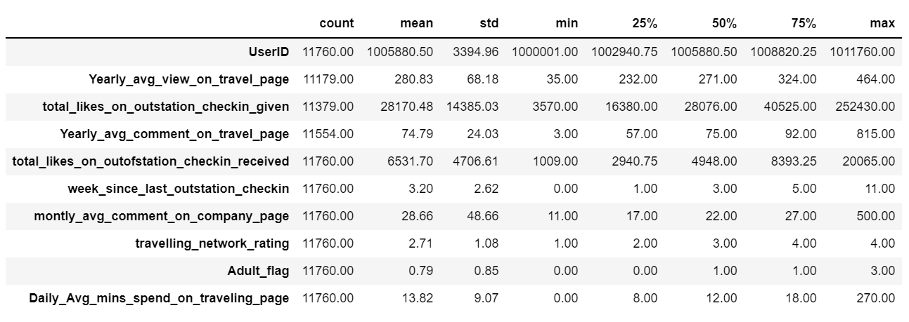

From the above stats we can observe the following:
- The mean of the yearly average views on travel page/company page is 280 while the minimum is 35.
- Daily average minutes spending on travelling page/company page by user is around 14 minutes while the minimum is 0 minute because most of the people do not even following the company’s page.
- The maximum number of week(s) since last outstation check-in for some user is 11, this means there are users who are not travelling outstation for any purpose and the minimum is 0 that exactly means there are users also who travel very frequently due to some reasons, but the standard deviation for the same variable is 2.6 which is close to the count of minimum (0) instead of maximum (11), which means that most of the people travels frequently.

c) Understanding of attributes (variables info, renaming if required)

- Variables info: Below are the names of the variables and their data types.
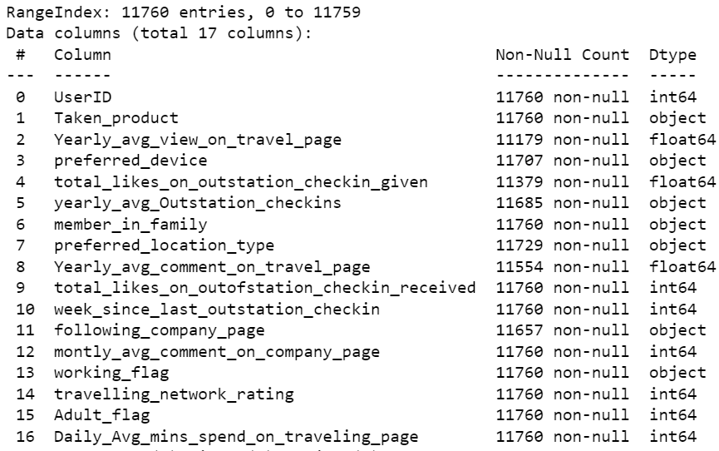
There are total 11760 entries range starting from 0 to 11759.
There are total 17 columns.
We can see that there are null/missing values also in few of the records in the dataset.
There are 3 variables with float data types, 7 variables with integer data types and 7 variables with object data types in the dataset.
Few of the datatypes are incorrect, we will change them accordingly.

- Renaming the columns for better understanding and readability
Replacing few long words in short abbreviations, like:
Taking Yearly average as YA, Daily average as DA, Preferred as Pref, Total likes as TL.
Similarly, outstation or out of station are same, so replacing it with OS.
Also, Travel page and Company page are same, so replacing it with CP.
I will drop user id column in the further step as it is not so useful for our analysis.
Also, the monthly average comment column is not so useful since we already have another column which is on yearly average comment basis.
Let’s look at the new column names after renaming them.
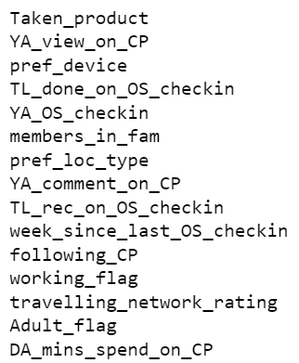

3. Exploratory Data Analysis
a) Dropping Unwanted columns:
I have dropped user id column, as it is not so useful for our analysis.
Also, the monthly average comment column is not so useful since we already have another column which is on yearly average comment basis.

b) Null/Missing value check in each columns:
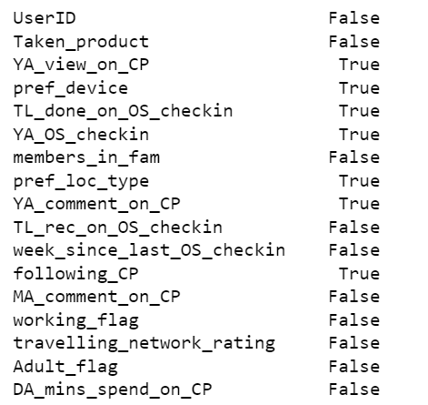
Boolean value ‘True’ indicates that there are missing values in the dataset, ‘False’ represent there are no missing values in those respective columns.
Now let’s check how many missing values are there in each column.
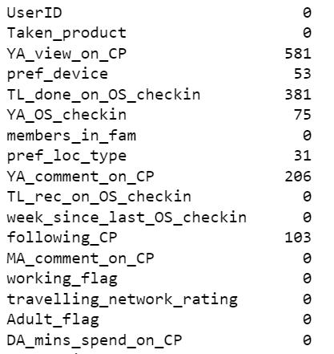
Few columns have missing values. Now let’s count total missing values.
Total null/missing values are: 1430
That means there are almost 12% of the data is missing. We cannot do further analysis without treating the missing values as it will affect our model and will create imbalance in the data.
Since, 12% is too much of data, we cannot impute any random values otherwise again this will impact our overall analysis.
We cannot impute those missing values with mean or median or mode since it will have a huge impact on the remaining data.
We will drop those all records with missing values.
Also, I have dropped user id column, as it is not so useful for our analysis.
Also, the monthly average comment column is not so useful since we already have another column which is on yearly average comment basis.
There is a special character, asterisk (*) was present in one of the column, so I have dropped that record also.
So, after dropping 1431 records and 2 columns we are left with 10455 records with no missing values.
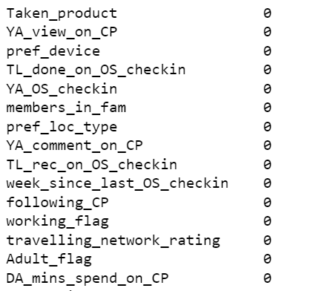

c) Univariate Analysis of Categorical variables:
We can also use count plot but here we are using histogram for all variables.
- For Taken_product (Whether the user has taken product or not)
- ‘No’ means - user who did not take the product are: 8762
- ‘Yes’ means - user who took the product are: 1693
- This means 84% of the user who did not take the product.
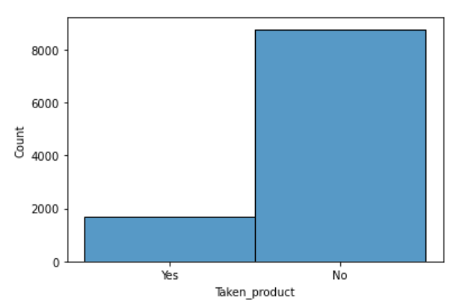
Fig.1. Histogram for Taken_product

- For Preferred_device (Preferred device for user to login):
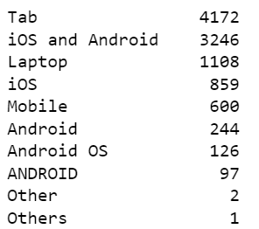
But as per the information given in the problem, that everything except Laptop is mobile. So, first let’s correct it.
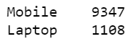
9347 users prefer mobile for login and 1108 users prefer Laptop for login.
This indicates that 89% of the users prefer mobile device for login.
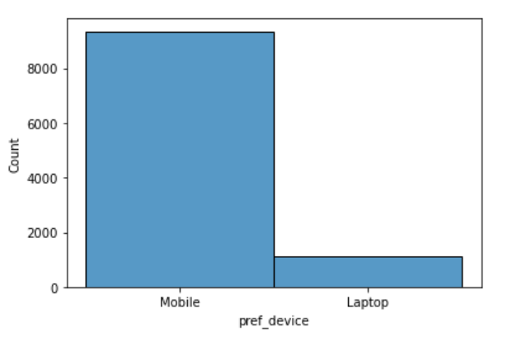
Fig.2. Histogram for pref_device

- Preferred Location Type (Preferred location type of the user):
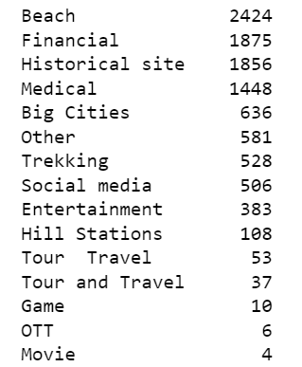
We can see that there are various preferred location type available in the data. Let's assign few of them into one category and organize them again.
1. We will take Beach, Historical site, Trekking, Tour Travel, Tour and Travel and Hill Stations in one category and will name it 'Adventure and Tourism'.
2. We will be replacing Game, OTT, Movie and Social Media with one already available category Entertainment.
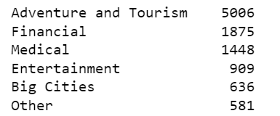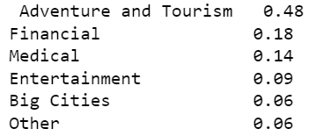

So after organizing the categories, we found out that:
- 'Adventure and Tourism' is the most preferred location type with 48%.
- 18% of the user has 'Financial' as their preferred location type, because they might travel mostly for business purpose.
- 14% of the user has 'Medical' as preferred location, as 14% of the user travel for their medical purposes.
- Only 9% of the users has 'Entertainment' as their preferred location type.
- ‘Big cities’ and ‘other’ is 6% each.
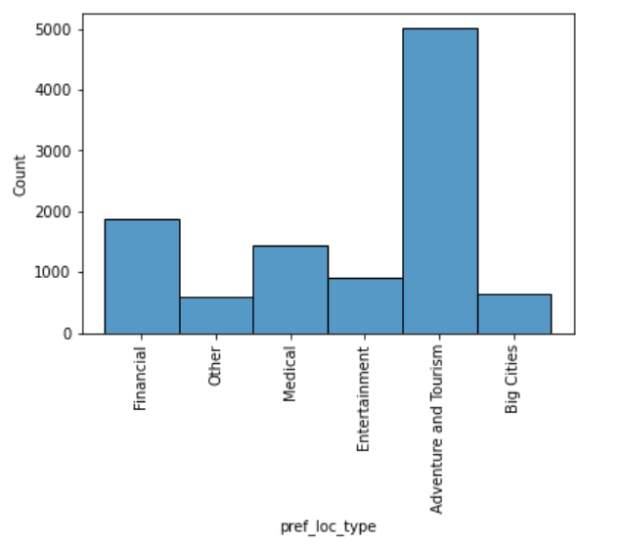
Fig.3. Histogram for pref_loc_type

- Following Company Page (Whether the user is following company page or not)
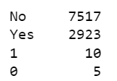
Here we need the data in the form of 'Yes' and 'No'. So we need to replace numeric value of 1 to Yes and 0 to No.
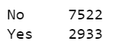
We see that only 28% of the users are following the company page and 72% still do not follow.
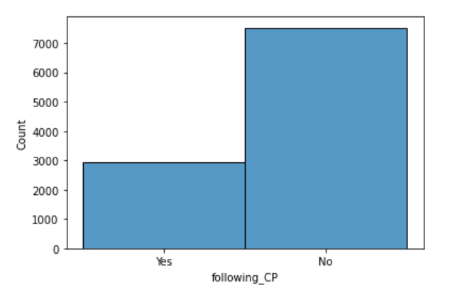
Fig.4. Histogram of following_CP

- Working Flag (Whether the user is working or not working)
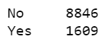
- 8846 users are not working.
- 1609 users are working.
- This means 85% of the users do not work anywhere. Only 15% users are working.
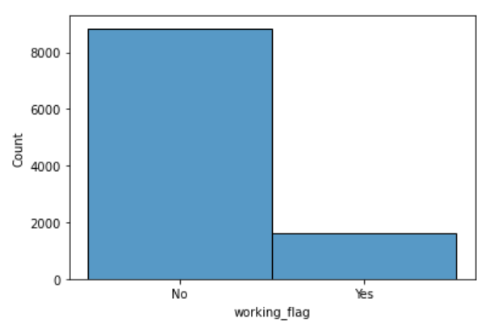
Fig.5. Histogram for Working_flag

- Members in Family (Number of members in user’s family)
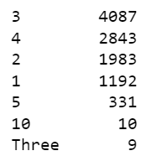
Instead of numeric 3, it is in alphabet form, let's replace/correct it.
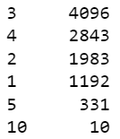
Most of the users have 3 members in their family.
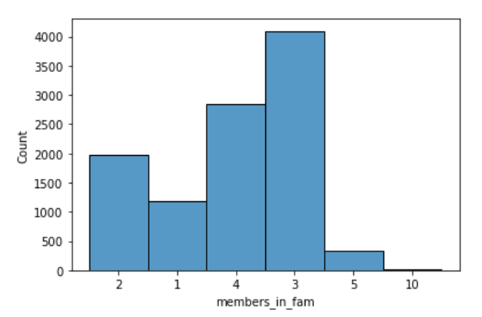

Fig.6. Histogram for members_in_fam

- Adult flag (Whether the user is adult or not)
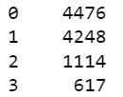
Here we will replace 2 and 3 with 1 because it's a categorical variable which must have only 2 options because a user can either be adult or not, so it should have values of either yes and no, or 1 and 0 and it can't be 2 and 3 in it. So, we will replace 2 and 3 with 1 and then count the sum of 0 and 1.
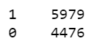
1 means user is adult and 0 means user is not adult.
So, this clearly means 57% of the users are adult.

Correction of data types:
As we have checked that few variables indicating the incorrect data types like:
1. 'YA_view_on_CP' should have integer type instead of float type.
2. 'TL_done_on_OS_checkin' should have integer type instead of float type.
3. 'YA_OS_checkin' should have integer type instead of object type.
4. 'members_in_fam' should have integer type instead of object type.
5. 'YA_comment_on_CP' should have integer type instead of float type.
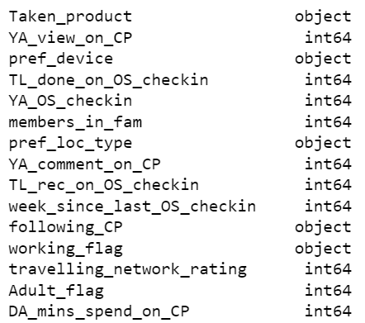

- Distribution plot for all continuous variables

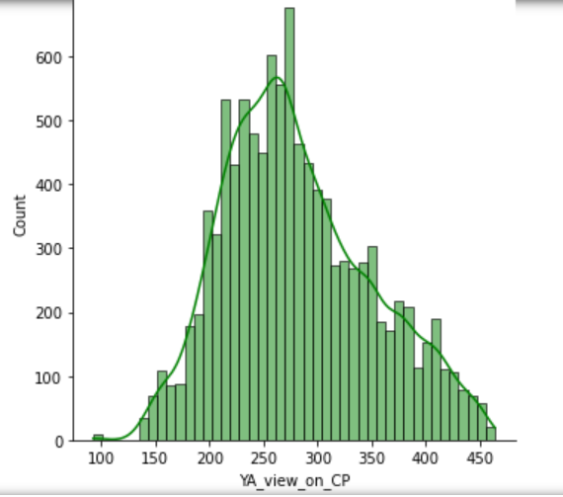

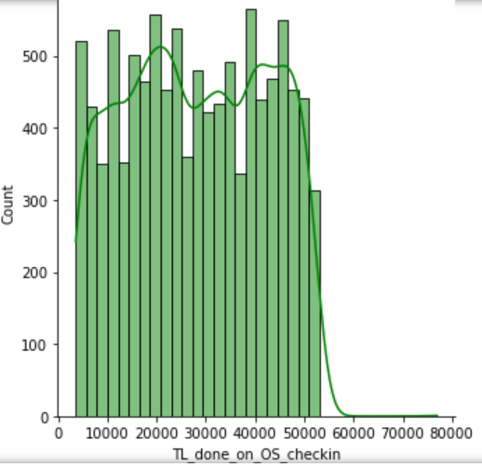

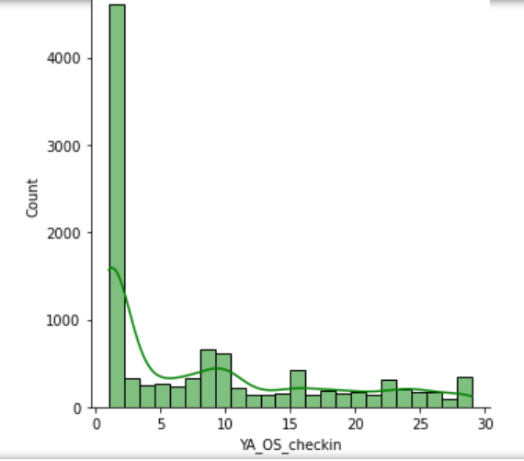

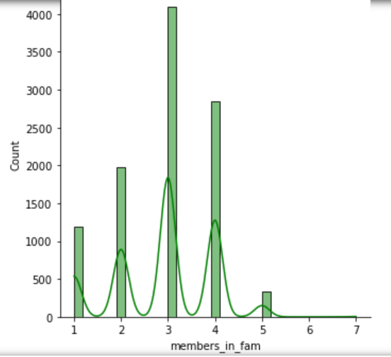

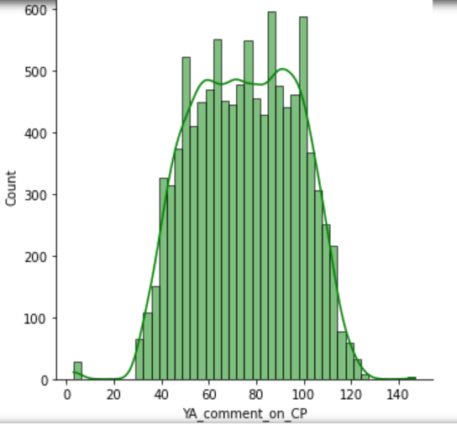

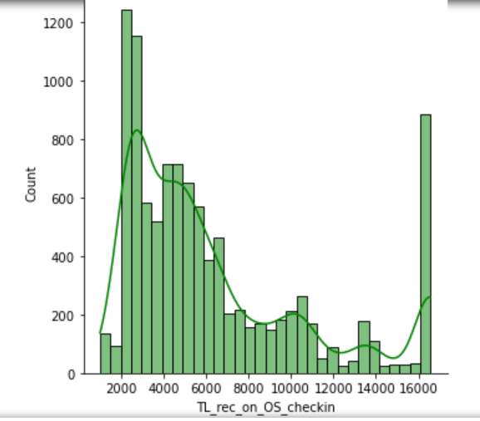

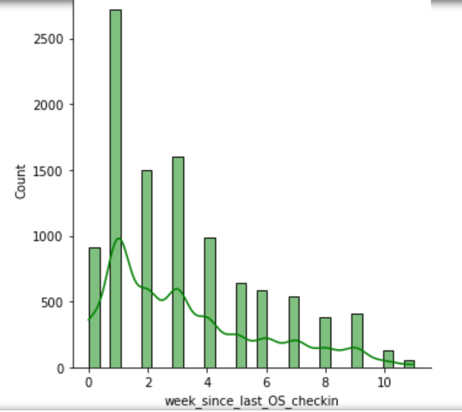

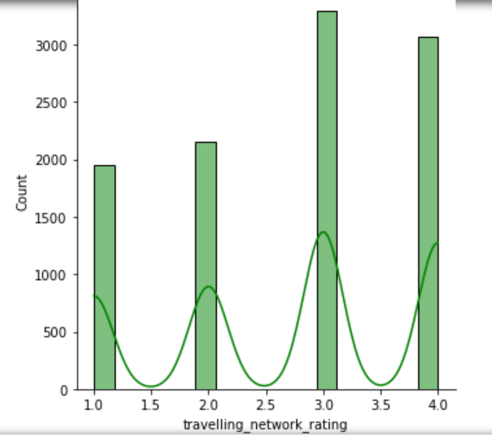

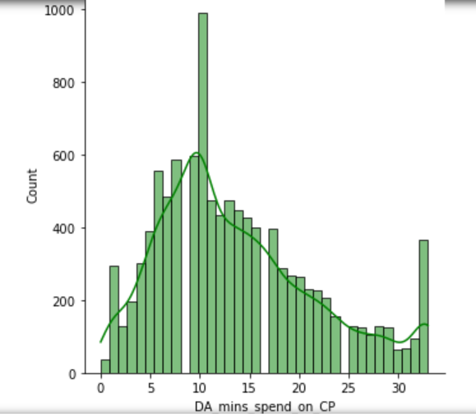

- Count plots
- Below is the count plot for Taken_product with the hue of following_CP, in which it is clearly visible that the majority of the users who have not taken the product are not following the company page.

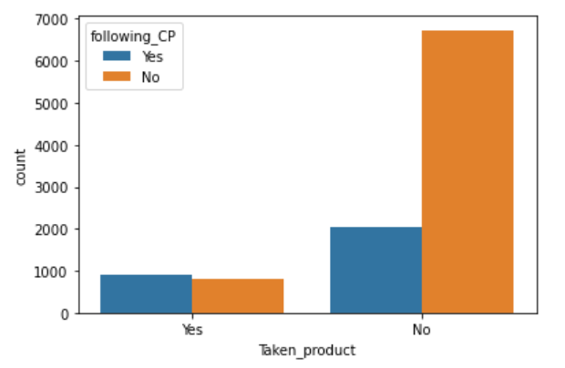

- Below is the count plot of Taken_product with the hue of Working_flag.

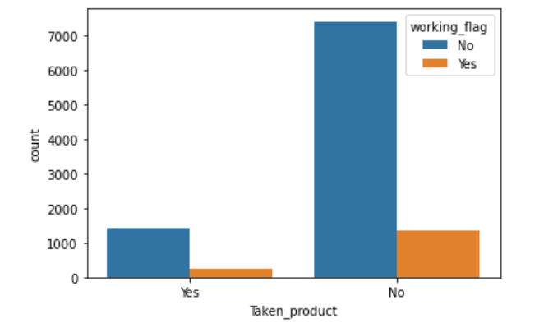

d) Outliers using box plot
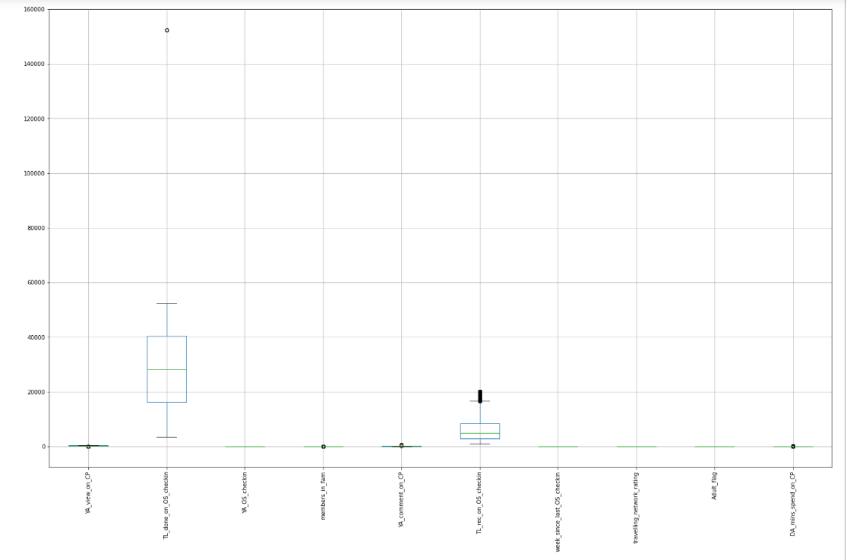

Fig.7. Boxplot for detecting outliers

It is not so clear from the above figure. Let’s look at each variable separately.
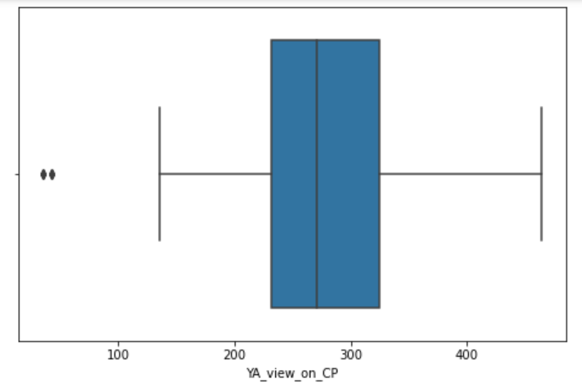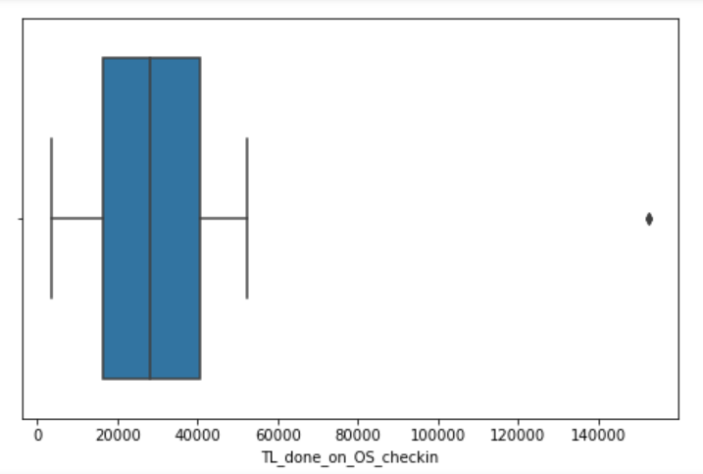
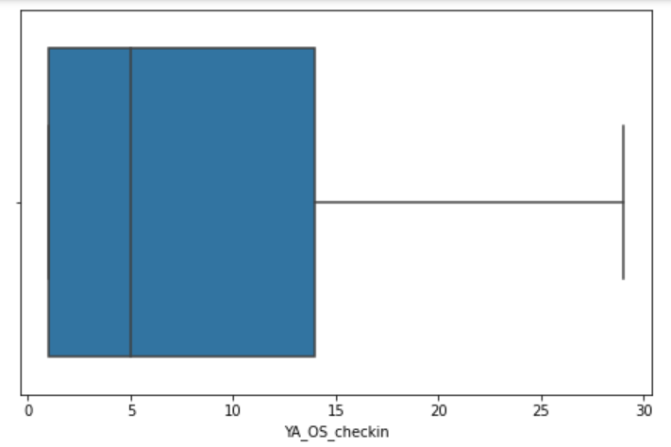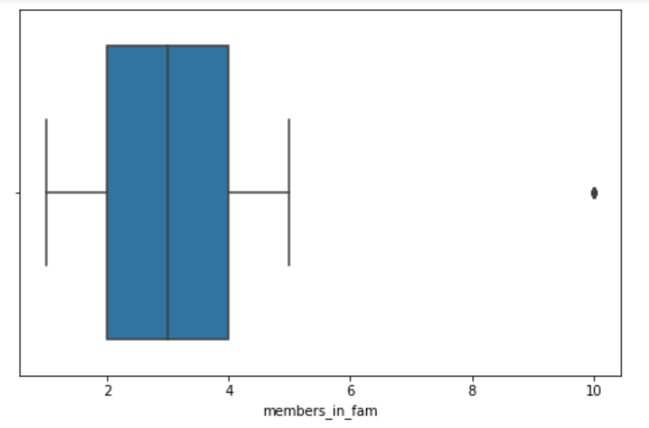

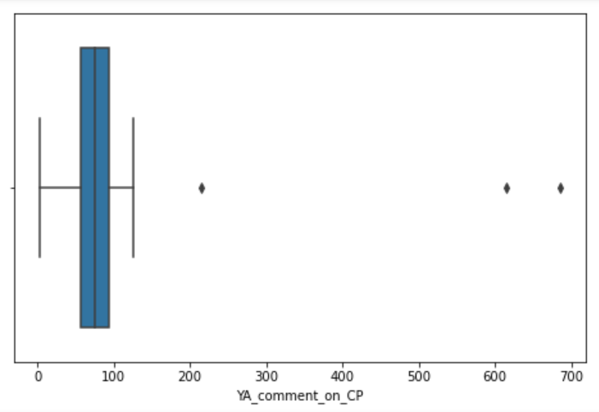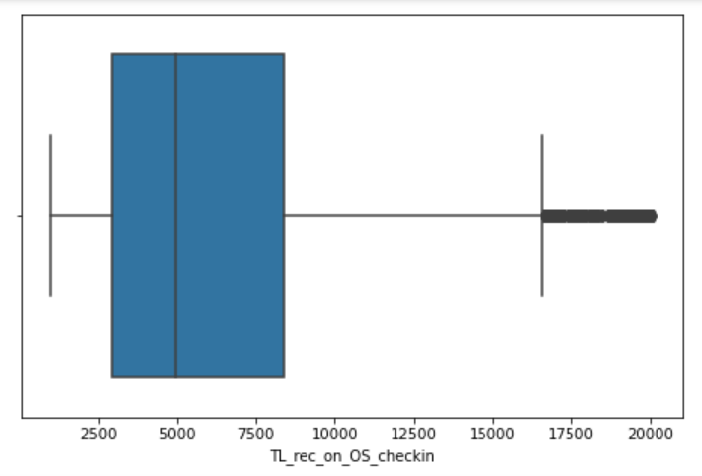

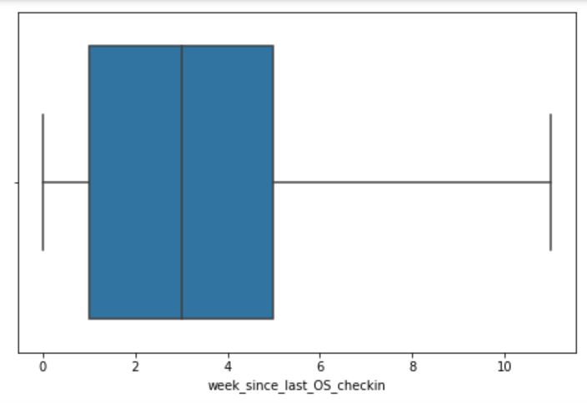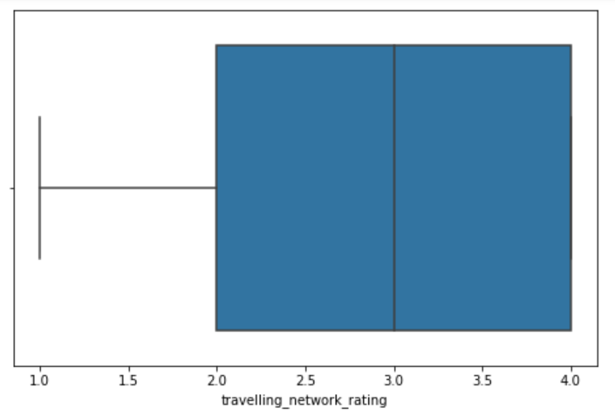

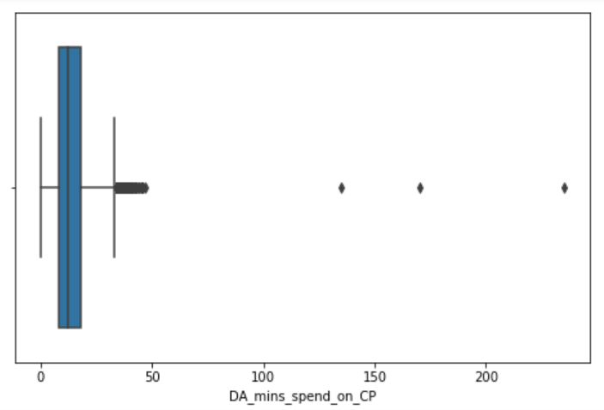

It seems like there are outliers present in the data set. Now let’s take a look at the count of them in each columns separately.
Here we are detecting the outliers using IQR method. This technique uses the IQR scores to remove outliers. The rule of thumb is that anything not in the range of (Q1 - 1.5 IQR) and (Q3 + 1.5 IQR) is an outlier, and can be removed.
Q1 means 1st quantile or 25th percentile.
Q3 means 3rd quantile or 75th percentile.
IQR means Inter Quartile Range, which is equal to Q3 – Q1.
By using Q1, Q3 and IQR we can calculate upper limit (UL) and lower limit (LL), where upper limit (UL) will be set to ‘Q3 + 1.5*IQR’ and lower limit will be set to ‘Q1 – 1.5*IQR’.
After calculating these values we have detected outliers in each column separately.
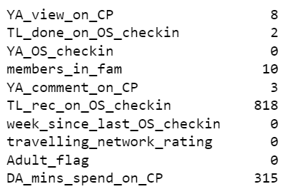
We can see that maximum number of outliers are present in ‘Total likes received on outstation check-in by user’ column which is equal to 818, followed by ‘Daily average minutes spending time on company’s page’ column which is equal to 315.
So, the total number of outliers present in the dataset = 1156, which is almost 10%.
We cannot replace the 10% of the data with some statistical values like mean or median because it might create the bias in our model building process, so we will remove those outliers permanently from our dataset.
Removing the outliers by defining a function is a good way of removing all the outliers at once. So, now let’s proceed with removing them.
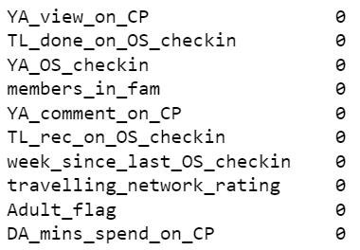

e) Correlation between variables using Heatmap
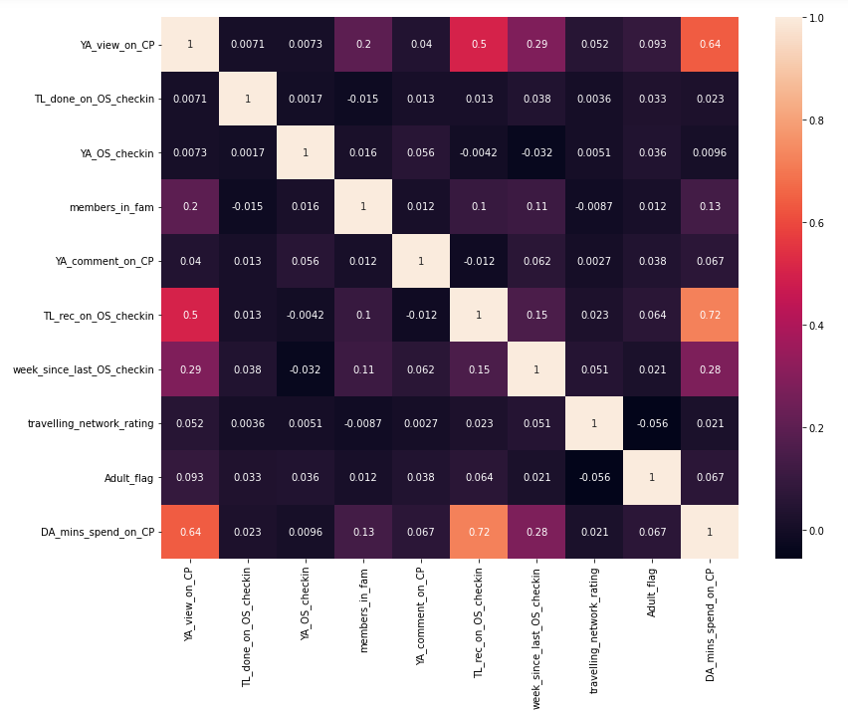

So here in the above Heatmap we can see that the light colors shows the highest correlation between 2 variables.

Highest correlated variables are:

1. 'TL_rec_on_OS_checkin' and 'DA_mins_spend_on_CP' (0.72)
2. 'YA_view_on_CP' and 'DA_mins_spend_on_CP' (0.64)
3. 'TL_rec_on_OS_checkin' and 'YA_view_on_CP' (0.5)

4) Business Insights from EDA

a) Is the data unbalanced? If so, what can be done? Please explain in the context of the business.
Yes, there is high imbalance in the data as we can see the users who did not take the product are much higher than the users who took the product. It means the distribution is not in a balanced way, it is much higher on one side. So in this case if we do under sampling for balancing our data then we might lose so much of our data which in the end will affect our model and the result will not be as useful as expected.

So over sampling can be done to balance the data.

b) Business Insights:
Some of the observations should be noted from our analysis till now are as follows:

There are more than 7000 users who are not following the company page and this is one of the reason that they are not getting any information and updates about the company and so many of them are not taking the product.

More than 8000 users are not working and most of them are not taken the product due to the reason that they might not want to spend much on travelling by air. They might be using some other ways of travelling.

Most of the users have 3 members in their family. That means they are the type of people who might be living out in some other cities due to their work and prefer travelling to some adventurous places with their family very often.

There are users who have done a lot of likes and comments on the outstation check-in, so we should focus more on such users and company can target to those user page for their advertisement. These kind of users are more easily attracted to the offers given by the companies.

